**TASK#1:** An automotive company wants to identify and treat outliers in their "mtcars" dataset. which contains information about various car models. They suspect that certain car models might have outlier values in certain variables and want to analyze and handle them using Python.Perform the following outlier detection techniques.

* Box Plot , Z-score, IQR range, Scatter

import pandas as pd

import numpy as np

import matplotlib.pyplot as plt

from pydataset import data

mtcars = data('mtcars')

variables_of_interest = ['mpg', 'disp', 'hp', 'drat', 'wt', 'qsec']

plt.figure(figsize=(10, 6))

mtcars[variables_of_interest].boxplot()

plt.title('Box Plot for Outlier Detection')

plt.xticks(rotation=45)

plt.show()

from scipy.stats import zscore

z_scores = zscore(mtcars[variables_of_interest])

abs_z_scores = np.abs(z_scores)

outliers_zscore = (abs_z_scores > 3).any(axis=1)

print("Outliers detected using Z-score method:")

print(mtcars[outliers_zscore])

Q1 = mtcars[variables_of_interest].quantile(0.25)

Q3 = mtcars[variables_of_interest].quantile(0.75)

IQR = Q3 - Q1

lower_bound = Q1 - 1.5 * IQR

upper_bound = Q3 + 1.5 * IQR

outliers_iqr = ((mtcars[variables_of_interest] < lower_bound) | (mtcars[variables_of_interest] > upper_bound)).any(axis=1)

print("\nOutliers detected using IQR method:")

print(mtcars[outliers_iqr])

plt.figure(figsize=(10, 6))

for var in variables_of_interest:

    plt.scatter(mtcars.index, mtcars[var], label=var)

threshold_value = 300

plt.axhline(y=threshold_value, color='r', linestyle='--', label=f'Threshold: {threshold_value}')

plt.title('Scatter Plot for Outlier Detection with Threshold')

plt.xlabel('Index')

plt.ylabel('Values')

plt.legend()

plt.show()

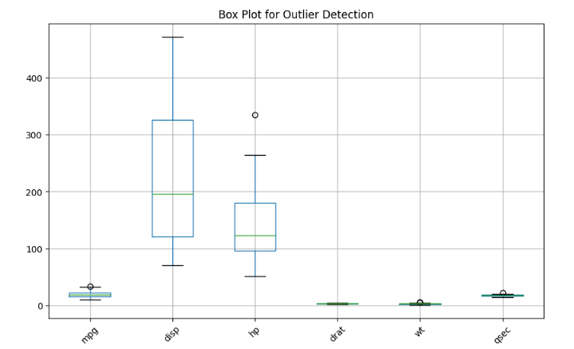

TASK#2: